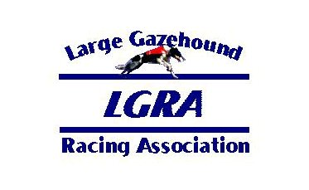
Club:__________________Date: ______

Breed:_______________________

QUICK ENTRY (For dogs that have previously raced in LGRA events):

LGRA NO:_________________ CALL NAME: ___________________________

LGRA NO:_________________ CALL NAME: ___________________________

LGRA NO:_________________ CALL NAME: ___________________________

FTE (First Time Entered Dogs):

CALL NAME: ____________________________________ SEX: _____________
REGISTERED NAME (Include titles):

________________________________________________________________________________________
SIRE:
____________________________________________________________________
DAM:
____________________________________________________________________

REGISTRATION PAPERS ATTACHED: AKC ________ NGA ________ AKC ILP ________ OTHER _______

FTE (First Time Entered Dogs):

CALL NAME: ____________________________________ SEX: _____________
REGISTERED NAME (Include titles):

_____________________________________________________________________________________
SIRE:
____________________________________________________________________
DAM:
____________________________________________________________________

REGISTRATION PAPERS ATTACHED: AKC ________ NGA ________ AKC ILP ________ OTHER _______

I and my heirs, legal representatives and assigns shall hold harmless and defend from any claim for personal injury, illness or property damage arising out of participation in this race meet sponsored by
__________________________________________, its officers, directors, committees, agents and members, and the Large Gazehound Racing Association, its officers, directors, committees, agents, and members. I agree to abide by the Official Rules and Regulations of LGRA and its code of conduct during this race meeting.

Signature of Owner Date

Owner’s Name (please print)

Address

E-mail _____________________________________________ Phone ___________________________

